We have uploaded all the core code, models, and maps used for the experiments. In addition, we have uploaded instructions for the entire data workflow from raw source data to analysis/modeling outputs for plotting or table building. We hope that these materials will assist the reviewers in their review.

For Figure 7, use the software OriginPro 2024 (64-bit) SR1 10.1.0.178 to open the file "ARScenes/Data/Figure 7.opju", select the four columns of data A, B, C, and D in Book 1, and choose"Plot→Statistical Chart→Boxplot" to get the analyzed results of Figure 7.

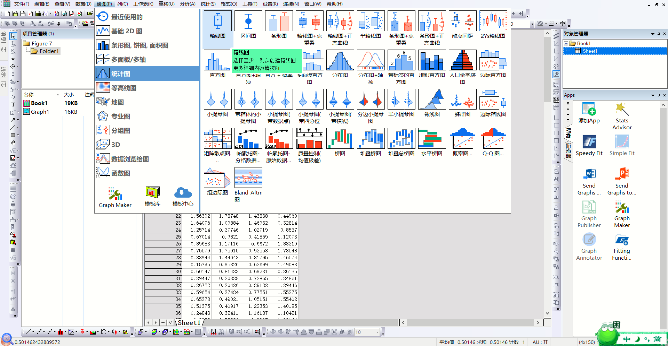

For Table 2, use the software IBM SPSS Statistics 25.0 to open the file "ARScenes/Data/Table 2.sav", and click on "Analyze→Nonparametric Test→Old Dialog→K Independent Samples".Click "Analyze→Nonparametric Test→Old Dialog→K Independent Samples".In the test type, select the Kruskal-Wallis test, click OK, output results.

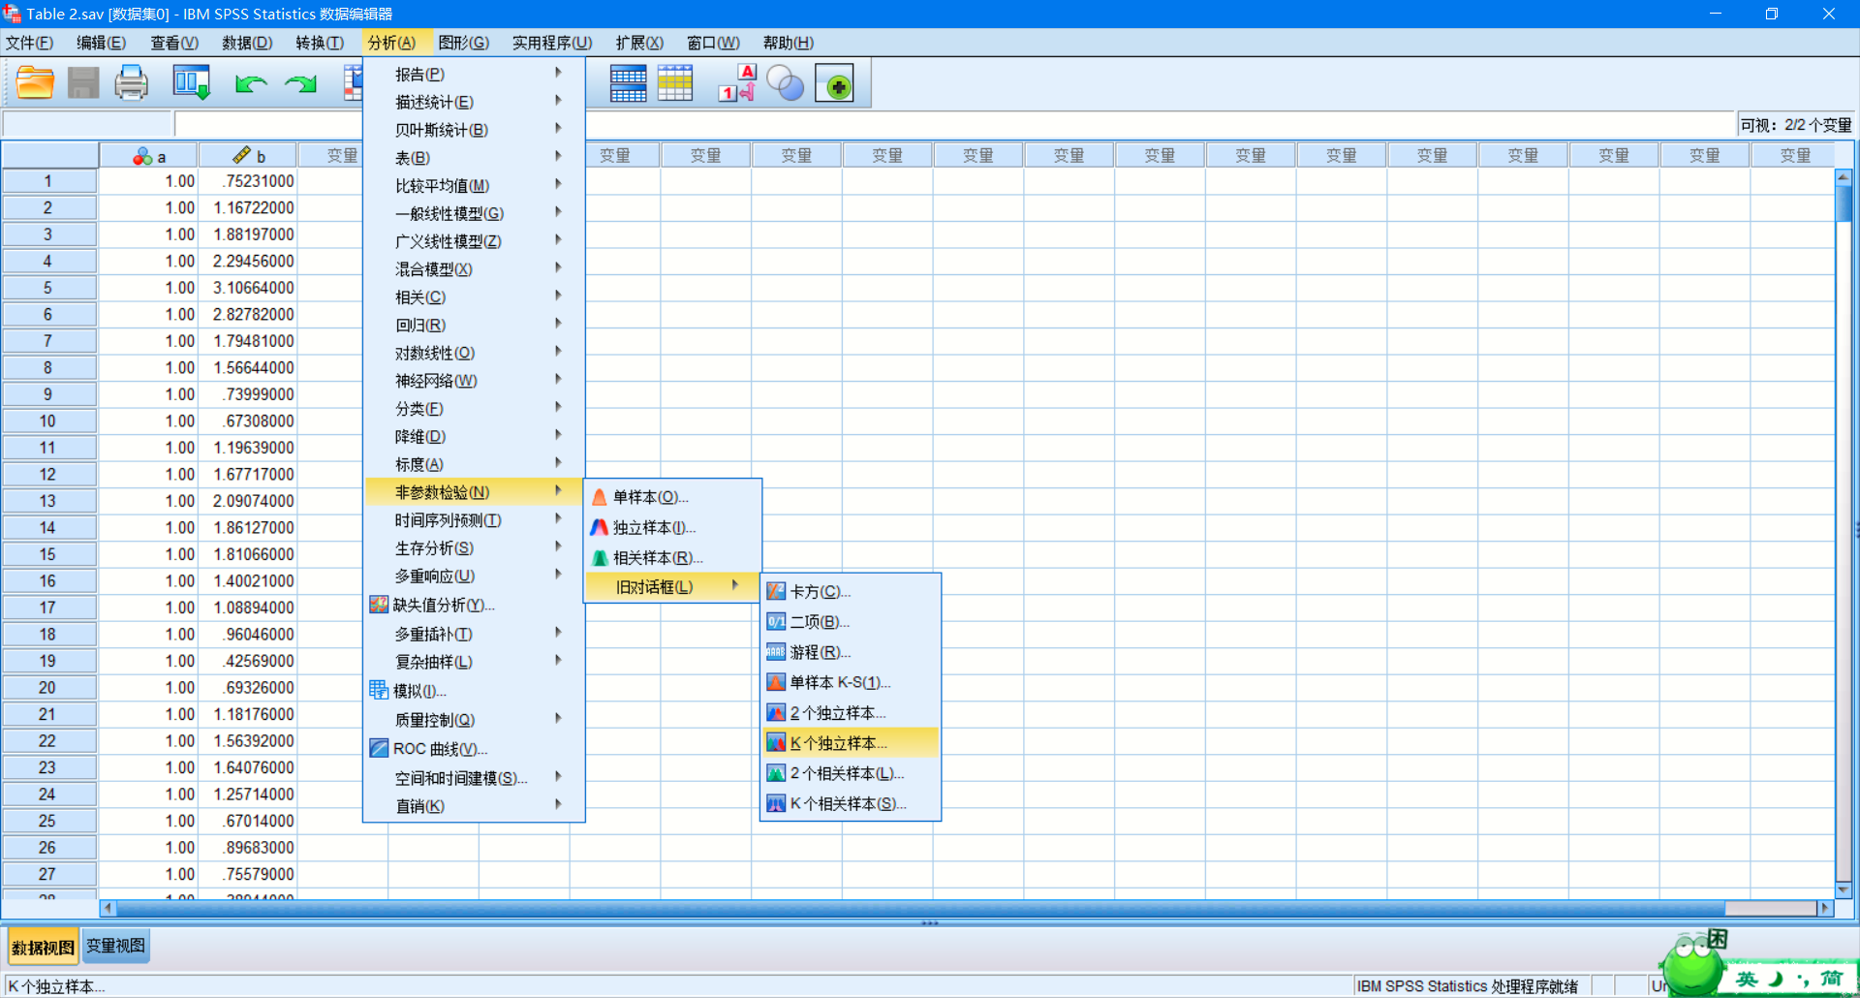

The Bonfereoni method with SPSS was used for the results of multiple independent samples rank sum test and multiple comparisons between groups.Click on "Analysis→Nonparametric test→Independent samples", click on "Settings", select "Customized test" in the interface, and select "Cruz".In the interface, select "customized test", choose "Crouse-Carl Wallis one-way analysis", select "All pairs" for multiple comparisons, and click "Run".

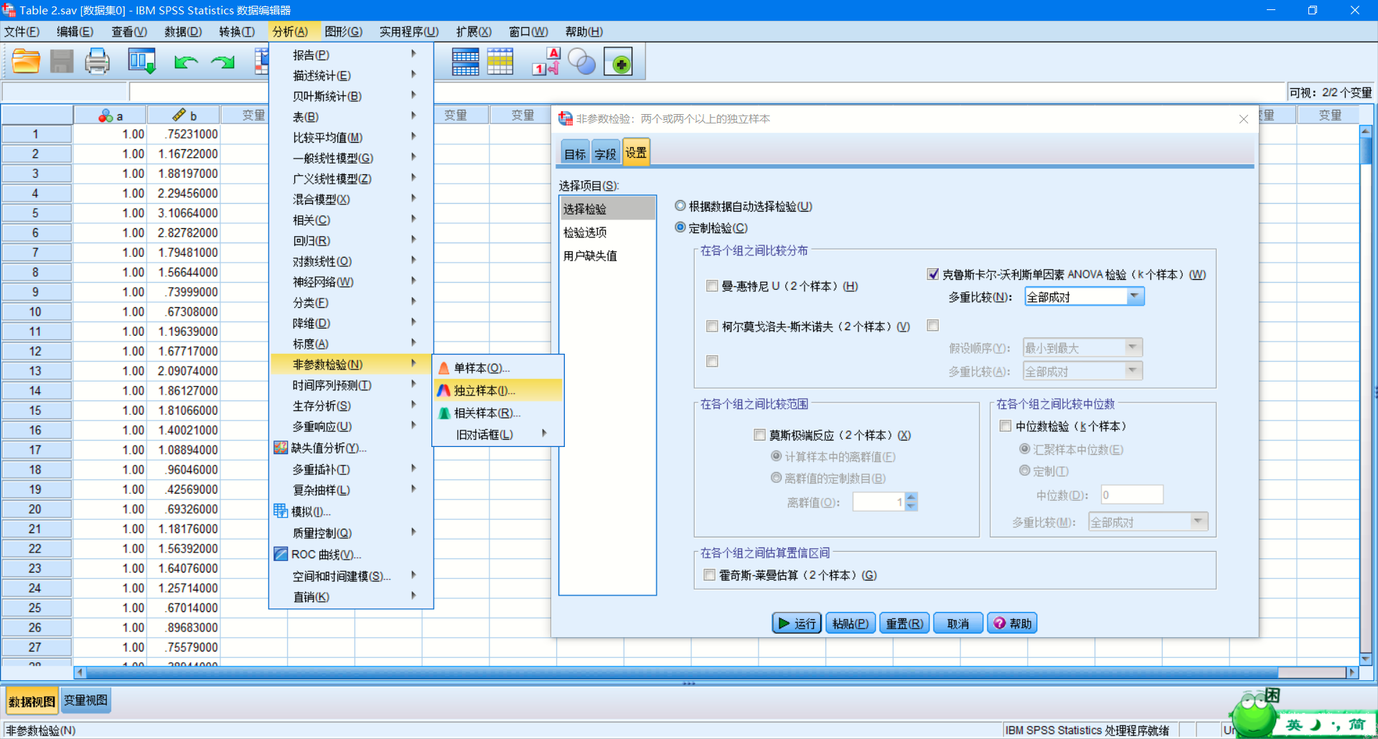

Figure 8 is generated by opening the file “ARScenes/ Data/ Figure 8 The effect of sampling rate on the average registration error.html” by the chart visualization plugin echarts.

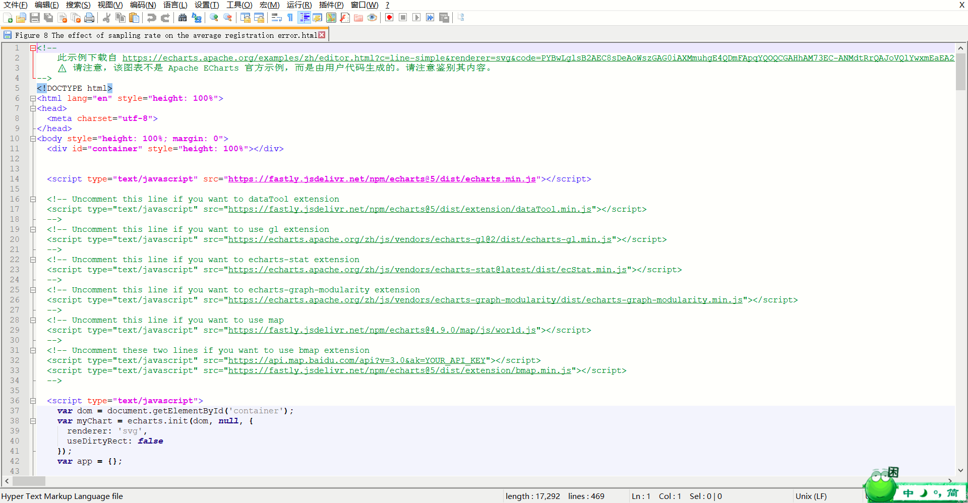

The result in Figure 10 can be generated by unity code, open the project folder "ARScenes/Code" with unity, and select different keyframe positions and numbers by using different methods.Check the "CameraDirection" script to generate the virtual view, replace the "DSM Mat" object with "Transparent Material" to extract the virtual object.Fuse the virtual object with the acquired request view image to generate the virtual fusion view in Figure 10.

